**Example: Mixing Drinks at Club Fever**

We are asked by Club Fever to come up with the optimal plan to mix drinks for a Thursday night. Excel file “Mixing Drinks.xlsx”

**Set up the Mixing Drinks model in Excel for Solver:**

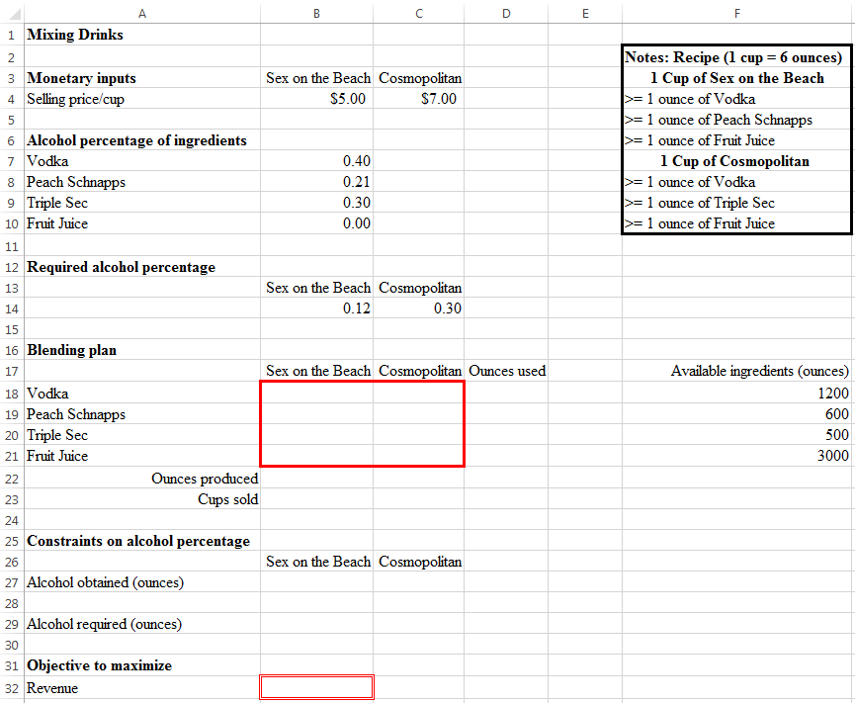

≤

=sum(B18:C18)

=sum(B18:B21)

=B22/6

≥

=B14*B22

=sumproduct($B7:$B10,B18:B21)

=sumproduct(B4:C4,B23:C23)

**Entering the Mixing Drinks model into Solver:**

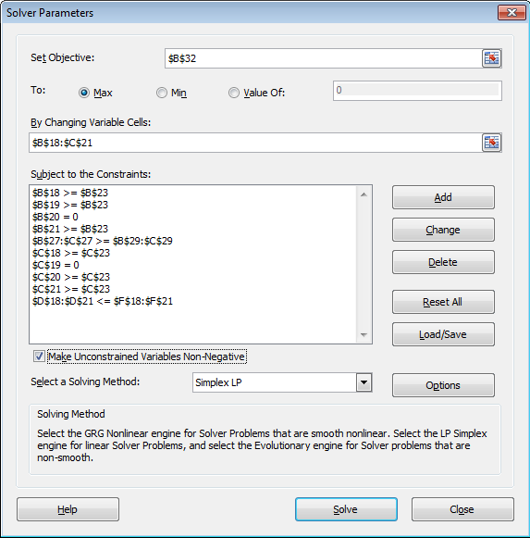

**Solution to the Mixing Drinks model:**

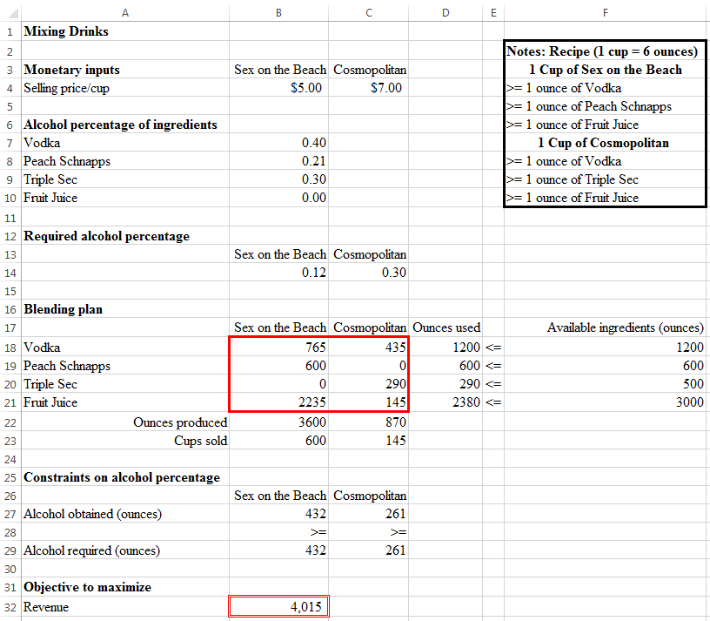

**Questions:**

1. With the above optimal mixing, Club Fever will obtain a revenue of $4,015.

2. If Club Fever need to produce at least 200 cups of Cosmopolitan, how should we modify the model? How would the revenue change as a result of this modification?

Add a constraint: C23 ≥ 200. Revenue would decrease to $3,942.

3. Based on the original model, how much is Club Fever willing to pay for 2 additional handles (60 ounces each) of Peach Schnapps?

Increase the available Peach Schnapps to 720 (= 600 + 2 * 60).

Revenue would increase to $4,258.

Maximum willingness to pay = $4,258 – $4,015 = $243.